43.51: 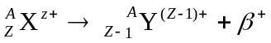
Adding (Z –1) electron to both sides yields
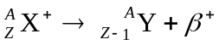
So in terms of masses:
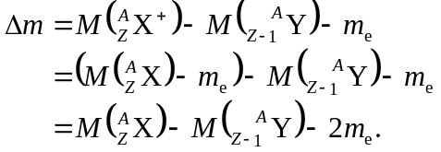
So the decay will occur as long as the original neutral mass is greater than the sum of the neutral product mass and two electron masses.

